EMERGENCY ASPIRATOR（AC/DC）



MODEL JX820D

Read this manual carefully before use
- Keep it permanently
Operating Manual

Date issued: 2016-04 Version: V1.2

EMERGENCY ASPIRATOR (AC/DC)
Model JX820D

GENERAL
Main functions: Temporarily and spontaneously suction of secretions, blood and body fluids which typically accumulate during respiratory tract suction and ENT treatment.
Medical Application: suction of the upper respiratory tract and throat, nose, ear.
Application organ: Upper respiratory tract (oral cavity, nasopharyngeal cavity and bronchial system) and throat, nose, ear
Application site: The application site of respiratory tract suction is the clinical, practices, nursing and home care sector. In ENT medicine the devices are used in clinic and practice.
The application of the device may only be performed by medical trained and introduced staff.
Contraindications: No application for the continuous operation in case of drainage in the low-vacuum range e.g. thoracic drainage or wound drainage.
No adapted for permanently endoscopic use.
No application outside of the medical sector.
No suction of ﬂammable, corrosive and explosive substances.
No application for introduced abortion and vacuum extraction.

SAFETY PRECAUTIONS
- Prior to starting up the Emergency Aspirator, please read these operation instructions carefully.
- The unit shall work continuously within 30 minutes with short-time loading. The duty cycle is more than 50%.
- Please note that the equipment is NOT suitable for continuous drainage.
- Please avoid using the unit near any flammable and /or volatile agents.
- The packed aspirators should be kept indoor with no corrosive gas and well ventilated.
- Don’t suction flammable, highly volatile liquid or gases.
- Disinfecting or sterilizing should comply with the method recommended by the manufacturer or comply with the relevant regulations of hospitals.
- Forbid laying the equipment into water or other liquid.
- Forbid laying anything on the adapter when operating or charging.
- The equipment should be operated with Air Filter and suction hose. Don’t connect the Phlegm catheter directly to the bottle’s patient joint, which marked “IN”
- Before connecting the unit to the mains supply, please ensure that the voltage of the unit should be consistent with that of the mains supply.
- Before operating, please test the function of this unit. If there is any doubt about the operation of this unit, please get in touch with supplier or manufacturer.
Warning: Don’t open the electrical equipment for any reason. If the equipment fails to operate, you must contact the manufacturer or agent for service recommendations. The equipment must only be opened by a service engineer or by qualified personnel.

FUNCTIONS AND OPERATIONAL PRINCIPLE (see Fig.1)
Model JX820D Emergency Aspirator (AC/DC) is a very handy small High Vacuum and High Flow portable suction unit. It is driven by a maintenance-free double piston cylinder pump. During operation, the pump generates a vacuum within the hose system and the storage bottle, thus sucking off secretions or fluids (e.g. by means of a suction catheter). No positive pressure to the applied part makes it safe and reliable to operate.
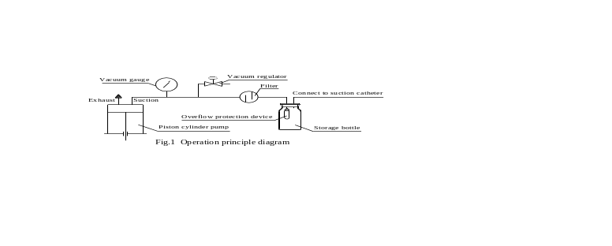
- Especially used for a patient who is transported by vehicle or is in a place without AC/DC power supply.
- Powered by three kinds of power supply－AC mains supply, external DC12V, and internal battery. The unit can work more than 60 minutes only powered by the internal rechargeable battery if it is fully charged. The unit can be immediately connected to the cigar lighter (DC12V) for transport use such as on ambulance;
- Powered by three kinds of power supply－AC mains supply, external DC12V, and internal battery. The unit can work more than 60 minutes only powered by the internal rechargeable battery if it is fully charged. The unit can be immediately connected to the cigar lighter (DC12V) for transport use such as on ambulance;
- The internal battery is charged with constant voltage and limited current while the unit is working or being attached to AC 100V～240V 50/60Hz or external DC 12V power supply. The capacity of the battery is respectively indicated by green, yellow and orange LED;
- The overflow protection device is intended to prevent liquid or solid particles from entering into the intermediate tubing.
- The vacuum can be step-less regulated by the vacuum regulator according to the clinical requirement.
- The vacuum gauge can display the current vacuum value;
- Equipped with a cleaning-cuvette which can reduce the probability of cross infection.
- The case and the container made of plastic material are light, compact, and easy to carry and operate.

CONSIGNMENT
- The unit has been strictly inspected and carefully packed before it was consigned;
- Before assembling and calibrating, please inspect the surface of the unit and the kinds and quantities of the accessories according to the parts list. Please contact the supplier or manufacturer in time if there are any problems.

LEGEND
 Attention of the documents!

ClassⅡ－the classification of electrical protection
Type B—the degree of protection against electric shock

Big and small arrow (Increasing or decreasing the vacuum)

INSPECTION AND ASSEMBLY
- Construction of the Storage Bottle (see Fig.2)
Vacuum Joint,
marked ‘OUT’
Air Filter
Suction Tubing
Lid Agraffe
Suction Hose

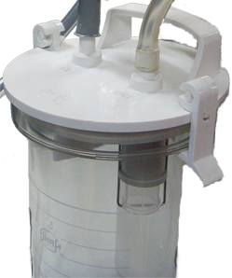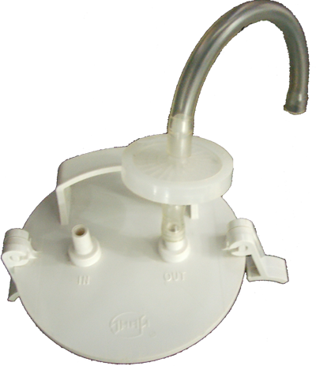
IN
OUT
Patient Joint,
marked ‘IN’

Fig.2 Construction of the storage bottle
Overflow Protection Device
Bottle Lid
Storage Bottle

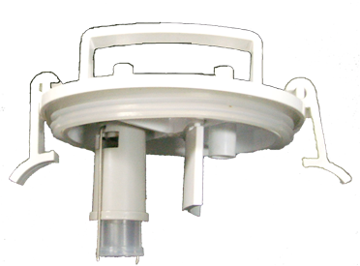

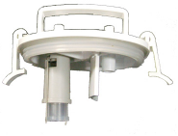
Fig.3 Bottle Lid

- Disengaging the Overflow Protection Device from the Bottle Lid (see Fig.3)
Open the bottle lid with overflow protection device, hold the overflow protection device with hand and twist counter-clockwise until it comes off the bottle lid.
- Check and Test Overflow Protection Device
- Pinch the float link of overflow protection device with hand, pull hard to the arrow direction on figure 5 until the float link is removed from the bottom edge slot of float rack (see Fig.5);
- Take the Float out of the Float Frame along the arrow (see Fig.6);
- Check whether the valve plate has deficiencies such as distortion, laceration, etc. and is firmly connected with the float. Then clean valve seat and valve plate (see Fig.7);
- Reassemble the overflow protection device in the reverse order and check whether the float can move flexibly in the shown direction in the float rack (see Fig.4);
- Reconnect the overflow protection device with the bottle lid;
- Carry bottle lid with hand to make the float contact water surface vertically. Move bottle lid downward slowly. The float shall float in the float rack.

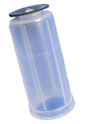
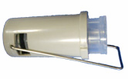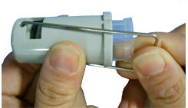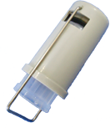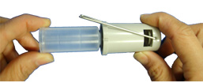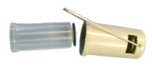
Float Frame
Fig.5
Fig.4
Metal Fastener
Fig.6
Rubber Valve Vane
Float

Fig.7

- Fasten the bottle lid, connect storage bottle with the machine and suction hose with “IN” suction joint of the bottle lid according to figure 2, and run the equipment with the regulator tightened clockwise.
- Extend the suction hose into a bucket of clean water or simulate normal operation to suck fluid into a solution bottle with overflow protection device. The rise of liquid level will drive the float to float upward until the valve port closes and the suction stops. The final liquid level will be different for different suction methods.
- Screw the vacuum regulator anti-clockwise, shut off the unit switch, open the Bottle Lid, and empty the Storage bottle. Re-assemble the lid tightly, and the Float should be located at the bottom of the overflow float frame with the valve entrance open.
The overflow protection device works normally and can be used clinically when the above conditions are met.
Note 1: When the overflow protection device acts, the continuous rise of liquid level may be caused by two factors: (1) remaining vacuum in the storage bottle; (2) valve port is not closed entirely. In the first circumstance, when the suction hose leaves the sucked liquid and is extended into it again, the liquid level in the solution bottle stops rising; in the latter circumstance, the liquid level still rises, which shall be observed carefully. When the solution bottle is nearly filled, pull out the suction hose from the sucked liquid immediately, close suction unit and stop suction, find the reason why the valve port fails to close.
Note 2: When the float closes the valve port, the suction stops. But for vacuum in the pipe, the float may be sucked into the valve port. At this time, stop the unit, release the vacuum in the pipe, and make the float drop freely.
It is strictly forbidden to pull the float hard with hand so as to prevent the rubber valve plate from being disengaged from the float.
Note 3: When the suction stops, the bottle lid can’t be opened until the vacuum in the pipe is released.
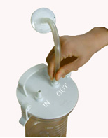
Note 4: Do not operate the apparatus without the overflow protection device.
Fig.8 connect to bottle
Green dot marked
- Connect the Air Filter to the Storage Bottle (see Fig.8)
Connect two suction tubing to the Air Filter, and then connect the other end of one of the suction tubing to the “OUT” connector on the Bottle Lid.
Please ensure that the inlet of Air Filter marked green dot should be connected to the “OUT” connector on the Bottle Lid.
- Connect the Storage Bottle to the Equipment
Please hang the bottle on the equipment and then connect the other end of suction tubing connected to the filter to the connector on the equipment.

OPERATION
- Connect to mains supply
Before connecting the unit to the mains supply, please ensure that the voltage of the unit should be consistent with that of the mains supply and the switch is in the “OFF” position. And when inserting the plug into the mains supply socket, the green charging LED illuminates.
The device that separates this unit from the mains supply is the plug of the power cord.
Fig.9 Capacity of the battery
- Usage of the battery
In case of being used, the internal battery capacity must be checked up for sufficiency before used according to the instruction as follows:
- Disconnect the power cord of the adapter from the mains supply, and then switch on the unit, and the Orange, yellow and green LED are lighting which means the battery is full charged (see Fig.9).
- Disconnect the power cord of the adapter from the mains supply, and then operate the unit only powered by the battery. It should be charged when only the orange LED is lighting. It will take about 6 hours when the battery is full charged. And for a used one, the charging time taken lies on the capacity left in the internal battery.
- If the internal battery doesn’t be used and is kept for a long-tern, the maintenance work to charge and discharge must be performed per six months (Run the unit disconnected from mains supply to discharge until only the orange LED lights and then charge up).
Note 1: When you replace the battery, connect the red wire to the positive pole of the battery, and the black one to the negative pole;
Note 2: The output of the adapter is 5A/DC12V. If a new one must be used, it is recommended to be provided by us;
Note 3: The unit can work more than 25 minutes only powered by the internal rechargeable battery if it is fully charged. When only the orange LED lighting, the battery should be charged.
Fig.10 Verify pipeline
- Usage of the power source of cigar lighter on vehicle
When the unit is used for emergency case on transport such as on ambulance, connect the plug of one end of the cigar lighter plug wire to the suitable socket on the side of the unit, then insert the plug of the other end into the cigar lighter socket on the vehicle，the lamp on the plug is lighting. In this case, the unit may be used and the battery can be charged.
- Usage of the manual switch
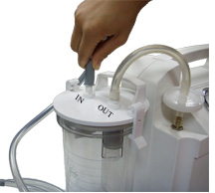
Before operating the unit with the manual switch, please insert the plug of the manual switch into the suitable socket on the side of the unit. Push the slip-block on the manual switch until the word “ON” appears and the unit is running. And then push it in reverse until the word “OFF” appears and the unit is stopping.
Fig.11 connect suction hose
- Verify pipeline(see Fig. 10)
Please switch ON the switch to start the unit with the connector marked “IN” on the Bottle Lid occluded, and turn the vacuum regulator clockwise or anti-clockwise and the vacuum gauge will vary between 0.02MPa and the max. vacuum. The level of vacuum can be adjusted by the regulator according to the clinical requirement.
Turn the vacuum regulator clockwise for increasing the vacuum
- 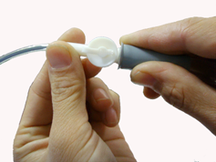Operation
Fig.12 connect the phlegm catheter
- Before use, inspect the apparatus according to the procedure of assembly, and ensure that your suction unit is in kilter. Turn the vacuum regulator clockwise or anti-clockwise until the clinical requirement is obtained (see Fig.10). Connect one end of the sterilized suction hose to the inlet of the Storage bottle and then connect the required phlegm catheter to the other end of the sterilized suction hose (see Fig.11 and 12). Now it is ready for operation.
Note: Please read carefully the packaging instructions of the phlegm catheter provided with the manufacturer before used. And inspect the package for damage; ensure that the phlegm catheter doesn’t expire.
- Before stop working, sucking a little clean water will be helpful to make suction hose clean.
- Usage of the cleaning-cuvette
Usually, some disinfectant solution can place in the cleaning- cuvette, which is used for placing catheter before or after operation.
- Stop Working
After adjustment or operation, please switch OFF and then pull out the plug from the mains socket to cut off the mains supply.

CLEANSING AND DISINFECTION
- General information on cleaning and disinfection
- For cleaning and disinfection, the apparatus must be disconnected from the mains supply!
- The measure described for cleaning and disinfection do not replace the respective regulation for operation.
- For disinfection, you may use all surface and instrument disinfectants listed in chapter 8.3 / 8.4.
- Some disinfection agents partly discolour parts of the lid and hoses, etc., however this has no effect on the properties of the materials.
- Do not use any
- disinfectants containing organic or inorganic acids or bases, as these can cause corrosion damage.
- disinfectants with chloramides, phenol derivatives or anionic tensides, as these can cause stress cracks in plastics used.
- Observe the disinfectant manufacturer’s instructions for use, especially the specifications on concentration and references to material compatibility.
- It’s recommended that cleaning and disinfection agents should be selected based on the hospital’s specific directives and cleaning practices and policies.
- It’s recommended that the cleaning and disinfection agents selected should comply with the requirements of CE
- Gloves (household or single use gloves) should be worn for cleaning and disinfection.
- Cleaning and disinfection
- After switching the apparatus, unscrew all hose and connectors, take the storage bottle out of the holder, open the lid, dispose of the content in accordance with regulations. The apparatus and the parts used should be cleaned and disinfected take the following list into account.
Part | Cleaning | Disinfection
Storage bottle | Thoroughly rinsed under running water. Using the cleaning agent neodisher AN or neodisher MediClean forte (manufactured by Dr. Weigert, Hamburg) cleaning in an automatic cleaner and disinfecter is also possible. | Place for an hour in disinfectant solution (see Instruction Manual) and then thoroughly rise and dry.
Lid
Cleaning- cuvette
Overflow protection device
Suction hose
Connection hose
Phlegm catheter | Only intended for single use; to be replaced after each use.
Housing / apparatus surface | Wipe with a cloth moistened with cleaning solution or disinfectant. Wring out the cloth before use so that no solution can enter through the openings in the housing. All of the cleaning solutions and disinfectants listed below can be used.
• After cleaning and disinfection, please re-assemble the Overflow Protection Device, the Bottle Lid and the Storage Bottle in the reverse order, and then connect these Tubing and the Suction Hose correctly (referring to 6. INSPECTION AND ASSEMBLY).
Note 1: The used Phlegm catheter should be disposed by the hospital according to the relevant regulations.
Note 2: The material of the cleaning- cuvette is glass, place take it carefully when cleaning and using.
- Recommended instrument disinfectants
Disinfectant | Contents | (in 100g) | Manufacturers
GIGASEPT FF  (Application concentrate) | Succinic acid dialdehyde  Dimethoxy tetrahydrofuran  Corrosion protection components  Non-ionic tensides and odoriphorers | 11g  3g | Schülke & Mayr, Norderstedt
Mucozit-T  (Application concentrate) | Bi3 (3-aminoprophyl) laurylamine  Alkyl dimethyl benzyl ammonium chloride  Cocospropylendiamine-1.5 guanidiniumacetate. | 8.0%  19.0%  7.0% | Merz & Co., Frankfurt/Main
Sekusept PLUS1  (Application concentrate) | Glucoprotamine  Non-ionic tensides, Solvents  Complexing agents | 25g | Ecolab, Düsseldorf
- Recommended surface disinfectants
Disinfectant | Contents | (in 100g) | Manufacturers
TERRALIN  (Application concentrate) | Benzal conium chloride  Phenoxypropanole | 20g  35g | Schülke & Mayr, Norderstedt
Incidin Plus  (Application concentrate) | Glucoprotamine  Non-ionic tensides, Solvents  Complexing agents | 26g | Ecolab, Düsseldorf
- Recommended cleaning agents
Cleaning agents | Contents | (in 100g) | Manufacturers
Neodisher MediClean forte  (Application concentrate) | Non-ionic tensides  NTA (nitrilotriacetic acid)  Enzymes, preservative agent | < 5 g  5-15 g | Dr. Weigert, Hamburg
Neodisher AN | Phosphate  Non-ionic tensides,  Enzymes | > 30 g  < 5 g | Dr. Weigert, Hamburg

MAINTENANCE
- Replacement for Air Filter
- If sucks much foam or is occluded by dirt, the Air Filter diaphragms will change its color from light to dark. And the suction in the inlet will reduce or disappear while the reading shown on the vacuum gauge is rising up to more than0.04MPa (300mmHg). Under this condition, please replace the Air Filter by a new one which is provided by the manufacturer.
- If the Air Filter is wetted or contaminated, please change it immediately.
- For hygienic reasons the filter must always be exchanged when the device is used in another patient.
- In case the device is used in one patient only, we recommend an exchange of the filter at least every two weeks.
- Pay attention to storing a sufficient number of replacement filters.
Note1: That the Overflow Protection Device operates or the tube has been occluded will also cause the suction to reduce or disappear while the vacuum gauge reading is still rising (see item 2 in “troubleshooting”).
Note2: The used Air Filter should be disposed by the hospital according to the relevant regulations
- Replacement for fuses
- The fuses of the mains supply fixed inside of the adapter should be replaced by professionals when required;
- When the fuses fixed inside of the cigar lighter plug wire should be replaced, please unscrew the nut on the top of the cigar lighter and replace it with a new one, and then re-assemble in the reverse order;
- The fuse fixed on the internal Printed Circuit Board (PCB) inside of the case should be replaced by professionals when required.

ELECTROMAGNETIC COMPATIBILITY
Safety warning：
- The equipment should be used in the electromagnetic environment limited by table 1, 2, 3 and 4.
- JX820D needs to be installed and put into service according to the EMC information provided in the Operating Manual.
- Portable and mobile RF communications equipment can affect the normal operation state of JX820D. It should be kept a distance from the portable and mobile communications equipment.
- The use of cables other than those specified, with the exception of cables sold by us as replacement parts for internal components, may result in increased Emissions or decreased Immunity of the equipment.
- JX820D should not be used adjacent to or stacked with other equipment and that if adjacent or stacked use is necessary, it should be observed to verify normal operation in the configuration in which it will be used.
Table 1
Guidance and manufacturer’s declaration – electromagnetic emissions
The equipment is intended for use in the electromagnetic environment specified below. The customer or the user of the equipment should assure that it is used in such an environment.
Emissions test | Compliance | Electromagnetic environment - guidelines
RF emissions CISPR 11 | Group 1 | The equipment uses RF energy only for its internal function. Therefore, its RF emissions are very low and are not likely to cause interference in nearby electronic equipment.
RF emissions CISPR 11 | Class B | The equipment is suitable for use in all establishments, including domestic establishments and those directly connected to the public low-voltage power supply network that supplies buildings used for domestic purpose.
Harmonic emissions  IEC 61000-3-2 | Class A
Voltage fluctuations/ flicker emissions  IEC 61000-3-3 | Conformity
Table 2
Guidance and manufacturer’s declaration – electromagnetic immunity
The equipment is intended for use in the electromagnetic environment specified below. The customer or the user of the equipment should assure that it is used in such an environment.
Immunity test | IEC 60601 test level | Compliance level | Electromagnetic environment - guidelines
Electrostatic discharge (ESD)  IEC 61000-4-2 | ±6 kV contact  ±8 kV air | ±6 kV contact  ±8 kV air | Floors should be wood, concrete or ceramic tile. If floors are covered with synthetic material, the relative humidity should be at least 30%
Electrical fast transient/burst  IEC 61000-4-4 | ±2 kV for power supply lines | ±2 kV for power supply lines | Mains power quality should be that of a typical commercial or hospital environment
Surge IEC 61000-4-5 | ±1 kV line to line | ±1 kV line to line | Mains power quality should be that of a typical commercial or hospital environment
Voltage dips, short interruptions  and voltage variations on power supply input lines IEC 61000-4-11 | <5% U_{T} (>95% dip in U_{T}) for 0.5 cycles  40% U_{T} (60% dip in U_{T}) for 5 cycles  70% UT (30% dip in UT) for 25 cycles  <5% UT (>95% dip in UT) for 5 sec | >95% for 10ms  60% for 100ms  30% for 500ms  >95% for 5000ms | Mains power quality should be that of a typical commercial or hospital environment. If the user of the equipment requires continued operation during power mains interruptions, it is recommended that the equipment be powered from an uninterruptable power supply or battery
Power Frequency Magnetic Field(50/60)Hz  IEC 61000-4-8 | 3A/m | 3A/m | Power Frequency Magnetic Field should be that of a typical commercial or hospital environment
NOTE U_{T} is the a.c. mains voltage prior to application of the test level
Table 3
Guidance and manufacture’s declaration – electromagnetic immunity
The equipment is intended for use in the electromagnetic environment specified below. The customer or the user of the equipment should assure that it is used in such an environment.
Immunity test | IEC 60601 test level | Compliance level | Electromagnetic environment - guidance
Conducted RF  IEC 61000-4-6  Radiated RF IEC61000-4-3 | 3Vrms  150kHz to 80MHz  3V/m  80MHz to 2.5GHz | 3Vrms  3V/m | Portable and mobile RF communication equipment should be used no closer to any part of the equipment, including cables, than the recommended separation distance calculated from the equation applicable to the frequency of the transmitter.  Recommended separation distance  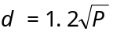  80MHz to 800MHz  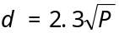 800MHz to 2.5GHz  Where P is the maximum output power rating of the transmitter in watts (W) according to the transmitter manufacture and d is the recommended separation distance in metres (m).  Field strengths from fixed RF transmitter, as determined an electromagnetic site survey,ª should be less than the compliance level in each frequency range. ^{b}  Interference may occur in the vicinity of equipment marked with the following symbol;  
Note 1: At 80 MHz and 800 MHz, the higher frequency range applies.
Note 2: These guidelines may not apply in all situations. Electromagnetic propagation is affected by absorption and reflection from structures, objects and people.
ª Field strengths from fixed transmitters, such as base stations for radio(cellular/cordless)telephones and land mobile radios, amateur radio, AM and FM radio broadcast and TV broadcast cannot be predicted theoretically with accuracy. To assess the electromagnetic environment due to fixed RF transmitters, an electromagnetic site survey should be considered. If the measured field strength in the location in which the equipment is used exceeds the applicable RF compliance level above, the equipment should be observed to verify normal operation. If abnormal performance is observed, additional measures may be necessary, such as re-orienting or relocating the equipment.
^{b} Over the frequency range 150 kHz to 80 MHz, field strengths should be less than 3V/m.
Table 4
Recommended separation distance between portable and mobile RF communication equipment and the equipment
The equipment is intended for use in an electromagnetic environment in which radiated RF disturbance are controlled. The customer or the user of the equipment can help prevent electromagnetic interference by maintaining a minimum distance between portable and mobile RF communications equipment (transmitters) and the equipment as recommended below, according to the maximum output power of the communications equipment.
Rated maximum output power of transmitter  W | Separation distance according to frequency of transmitter  m
Rated maximum output power of transmitter  W | 150 kHz to 80 MHz  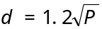 | 80 MHz to 800 MHz  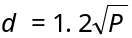 | 800 MHz to 2.5 GHz
0.01 | 0.12 | 0.12 | 0.23
0.1 | 0.38 | 0.38 | 0.73
1 | 1.2 | 1.2 | 2.3
10 | 3.8 | 3.8 | 7.3
100 | 12 | 12 | 23
For transmitter rated at a maximum output power not listed above, the recommended separation distance d in metres (m) can be estimated using the equation applicable to be frequency of the transmitter, where P is the maximum output power rating of the transmitter in watts (W) according to the transmitter manufacturer.
Note 1: At 80 MHz and 800 MHz, the higher frequency range applies.
Note 2: These guidelines may not apply in all situations. Electromagnetic propagation is affected by absorption and reflection from structures, objects and people.

TECHNOLOGY DATA
Item | Data | Item | Date
Max vacuum | 0.08MPa | Rated voltage | 100V－240V 50/60Hz, DC12V
Vacuum range | 0.02 MPa～Max. vacuum | Power input | 110 VA
Flow rate | 20 L/min | Electrical protection | Class Ⅱ 
Bottle capacity | 1000 mL | Degree of protection | Type B
Noise | 65 dB(A) | Degree of protection provided by enclosure | IPX3
Working time | Maximal 30 min | Medical device classification | Class Ⅱa
Battery working time | 25 min | Net weight | 4.5kg
Battery | Lead-acid | Dimension(W×D×H) | 450mm×200mm×320mm
Fuse | RT1 310 3A/250V  (Adapter)  RF1 520 10AL/250V  (PCB)  RF1 630 4AL/250V  (Cigar lighter) | Environment in normal use | Temperature: 5~40C  Relative humidity: ≤ 80%  Atmospheric pressure:  860~1060 hPa
Fuse |  | Environment in transport or storage | Temperature: -40~55C  Relative humidity: ≤ 95%  Atmospheric pressure:  500~1060 hPa

TROUBLESHOOTING
Item | Fault | Cause | Solution | Remarks
1 | The vacuum value can not reach to the max. vacuum | 1) Leakage in the entrance of the Storage bottle.  2) Vacuum regulator loose.  3) Leakage in the tubing connection. | 1) Cleaning the entrance of the Bottle and press the Bottle lid tightly.  2) Screw down the regulator  3) Make the tubing be connected correctly. | 1) Uneven lid may result in leakage. Replace the lid if necessary  3）Reconnect the tube or replace some damaged tube
2 | Vacuum value 0.04MPa，but the suction force in the entrance of tubing obviously reducing or disappearing. | - The overflow  protection device  operates  2) Suction tubing is occluded.  3) Air Filter is blocked. | 1) Turn the vacuum regulator anti-clockwise to release the vacuum, and then return it clockwise.  2) Clean the tube or replace it  3) Replace the Air Filter by a new one. | 1）Empty the storage bottle in time.  2）The end with green dot mark of the Air Filter is the entrance of air flow
3 | Power supply is well, but the unit fails to operate and the charging LED does not illuminate. | 1) The plug and socket contacts fault.  2) The fuse is fusing. | 1) Repair or replace the socket.  2) Replace the broken fuse. | 2）Fuse  RT1 3×10 3A/250V  RF1 5×20 10A/250V  RF1 6×30 4A/250V
4 | Connected to mains supply, the fuse is broken immediately. | 1) Electrical fault  2) Over-voltage | 1) Examine the circuit to work out the problem. | Examining or repairing by professionals ( see Fig.13 Circuit diagram )
5 | Liquid sucked into pump spurts out from the exhaust | There is some fault in the overflow protection device | Repair or replace the Defective Overflow Protection Device. (referring to 6.3. Check and test overflow protection device) | Use the storage bottle with the liquid not more than its stated capacity.

Note: It is recommended that the pump should be opened or repaired by professionals. If necessary, please get in touch with the manufacturer.
Fig.13 Circuit Diagram

WASTE DISPOSAL
At the end of the useful life of the unit, all of the waste parts should be disposed according to the rules of waste disposal:
  - The storage bottle, all of the tubing, the Suction Hose and cleaning- cuvette belong to medical garbage.
  - The basic configuration of the unit and the adapter can be disposed as electronic waste.
  - The material of the unit case is ABS, which can be recycled.

SERVICE
  - Any of our products is promised to be repaired free or replaced within one and a half years from the date of ex-factory or within one year from the date of purchasing if it is out of order. Above all, the packed unit should be stored well and operated complying with the rules recommended by the manufacturer.
  - Circuit diagrams, part lists and other technical information are available upon request for qualified technical personnel.

ACCESSORIES
  - Fuse (RF1 φ5×20 10AL/250V) 2 pc
  - Air Filter 2 pc
  - Suction hose (φ7.5×11.5mm, 2m) 1pc
  - Adapter (DC12V 5A) 1pc
  - Power cord 1pc
  - Plug of cigar lighter for vehicle 1pc
  - Manual switch 1 pc

Before the products are put to the market, they have been examined according to the requirement of the relevant standard, all meet such requirement and are qualified.

Design and specifications changed reserved.

